Q1. STATEMENT: Write a program to print all the possible values an integer variable can have.

CODE:
#include <stdio.h>
int main()
{
short int a=0;
do
{
printf("%d\t",a);
a++;
} while(a);
return 0;
}
OUTPUT:
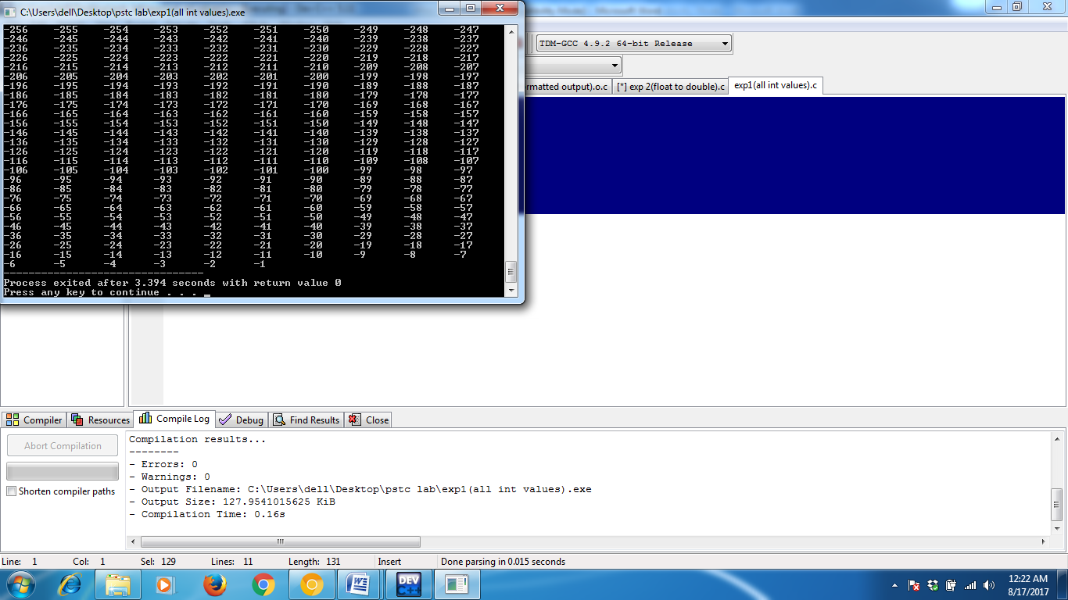

Q2. STATEMENT: Write a program to convert float to double.

CODE:
#include <stdio.h>
int main()
{
double a;
float b;
printf("Enter a floating point number : ");
scanf("%f",&b);
a=(double)b;
printf("Double Number is %lf",a);
return 0;
}
OUTPUT:
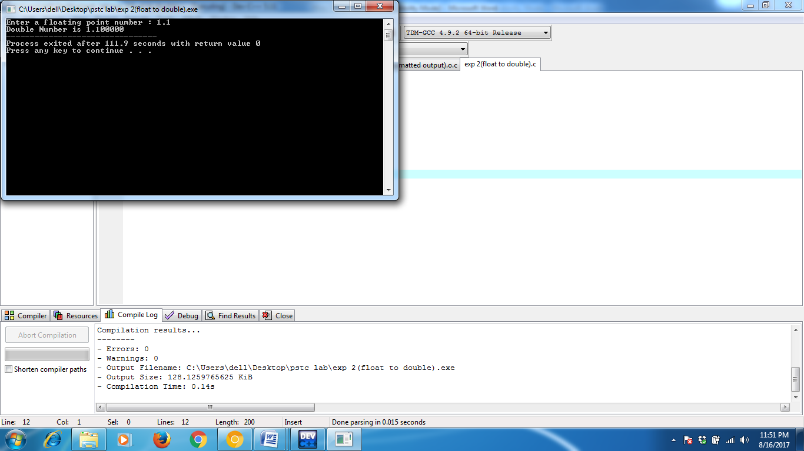

Q3. STATEMENT: Write a program to convert double to float.

CODE:
#include <stdio.h>
int main()
{
double a;
float b;
printf("Enter a double number : ");
scanf("%lf",&a);
b=(float)a;
printf("Floating Number is %f",a);
return 0;
}
OUTPUT:
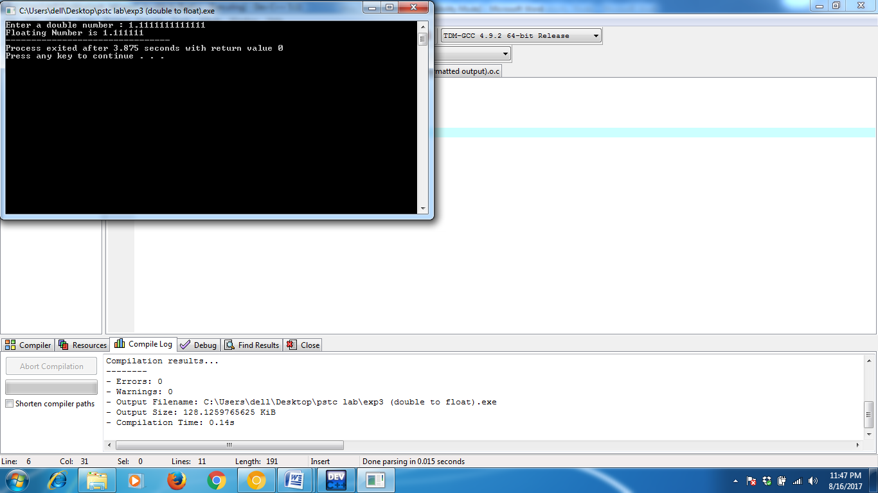

Q4. STATEMENT: Write a program to find the size of all the data types

CODE:
#include <stdio.h>
int main()
{
printf("sizeof(int) : %d bytes\n",sizeof(int));
printf("sizeof(char) : %d bytes\n",sizeof(char));
printf("sizeof(float) : %d bytes\n",sizeof(float));
printf("sizeof(double) : %d bytes\n",sizeof(double));
printf("sizeof(long) : %d bytes\n",sizeof(long));
printf("sizeof(short) : %d bytes\n",sizeof(short));
printf("sizeof(double) : %d bytes\n",sizeof(long double));
return 0;
}

OUTPUT:
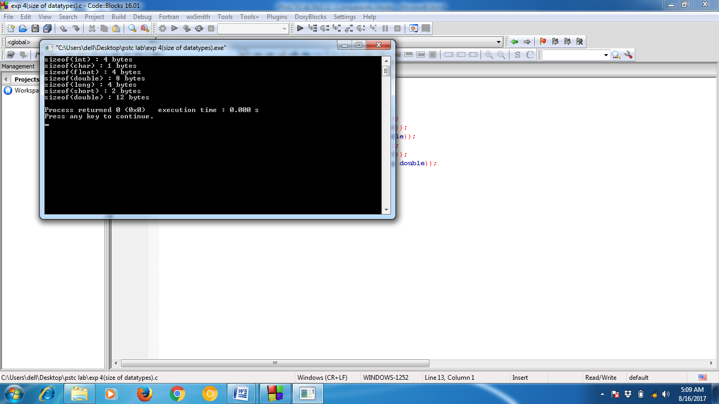

Q5. STATEMENT: Write a program to convert decimal number to octal number.

CODE:
#include <stdio.h>
int main()
{
int num=0,oct=0,rem=0,i;
printf("Enter a decimal number : ");
scanf("%d",&num);
// printf("Octal number : %d",oct);

for(i=0;num;i++)
{
rem=num%8;
oct+=pow(10,i)*rem;
num=num/8;
}
printf("%o",num);
}
OUTPUT :
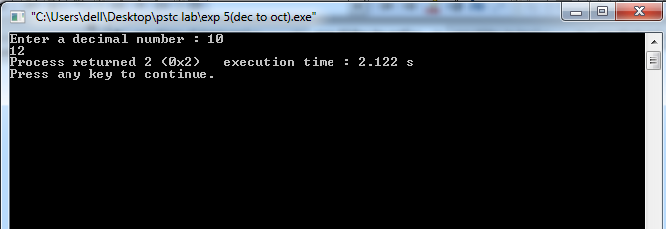

Q6. STATEMENT: Write a program to convert decimal number to hexadecimal number.

CODE:
#include <stdio.h>
int main()
{
int num;
printf("Enter the number : ");
scanf("%d",&num);
printf("Hexa-decimal number : %x",num);
return 0;
}

OUTPUT:

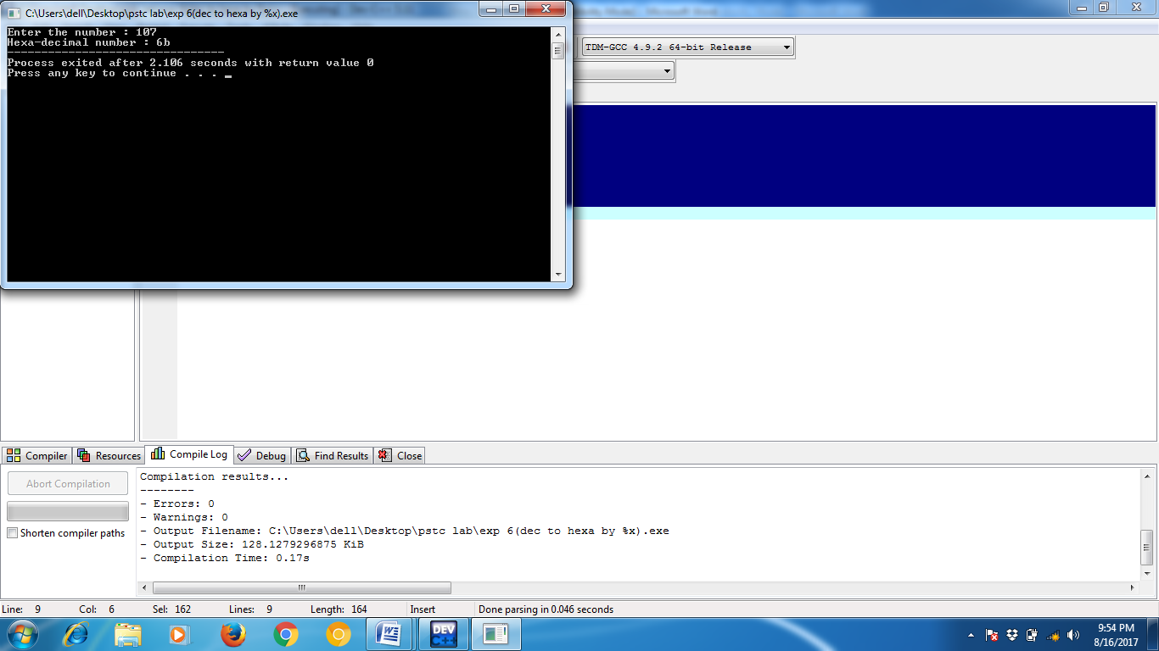

Q7. STATEMENT: Write a program to print formatted output.

CODE:
#include <stdio.h>
#include <math.h>
int main() {
int i,j,num=3;
char ch;
for(i=-num;i<=num;i++) {
ch='A';
for(j=-num;j<=num;j++) {
if(abs(i)+abs(j)>num) {
printf("%c",ch);
ch++;
} else {
printf(" "); }
}
printf("\n");
}
return 0; }
OUTPUT:
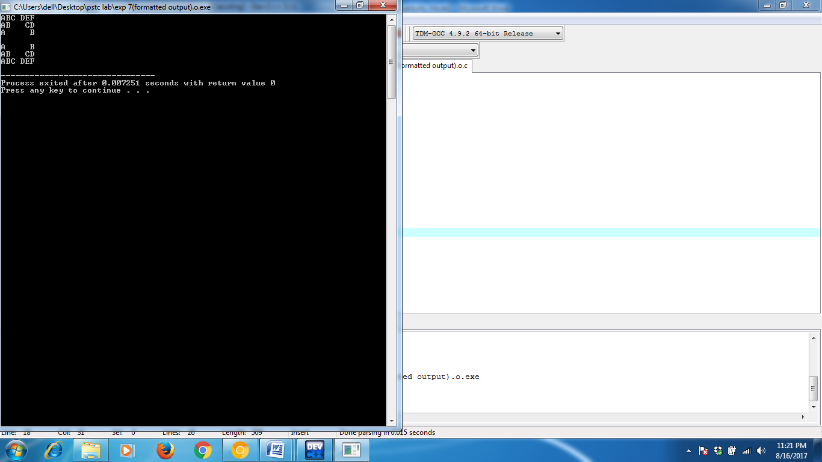
Q8. STATEMENT: WAP to print nth bit of a given integer.

CODE:
#include <stdio.h>
int main()
{
int num,n,bit;
printf("Enter the number : ");
scanf("%d",&num);
printf("Enter n : ");
scanf("%d",&n);
bit=1&(num>>(n-1));
printf("%dth bit of %d is %d",n,num,bit);
return 0;
}

OUTPUT:

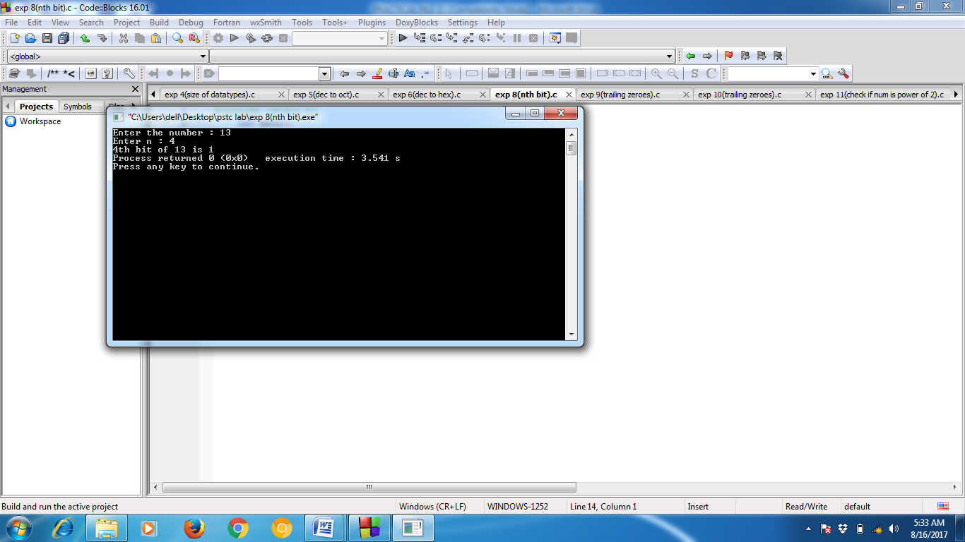
Q9. STATEMENT: WAP to find the number of trailing zeros in a given integer.

CODE:
#include <stdio.h>
int main()
{
int num,count=0,i=1;
printf("Enter the number : ");
scanf("%d",&num);

while(!(num&i))
{
count++;
i<<=1;
}
printf("Trailing Zeroes : %d",count);
return 0;
}
OUTPUT :
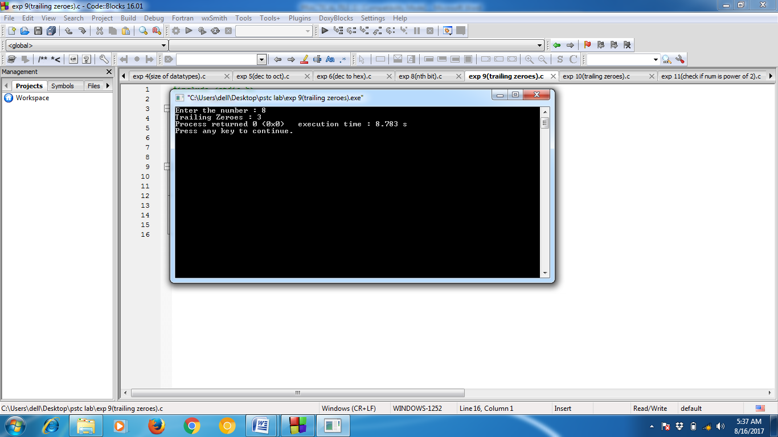
Q10. STATEMENT: WAP to find the number of trailing zeros in a given integer (in binary format).

CODE:
#include <stdio.h>
int main()
{
int num,count=0,i=1;
printf("Enter the number : ");
scanf("%d",&num);

while(!(num%10))
{
count++;
num/=10;
}
printf("Trailing Zeroes : %d",count);
return 0;
}
OUTPUT :
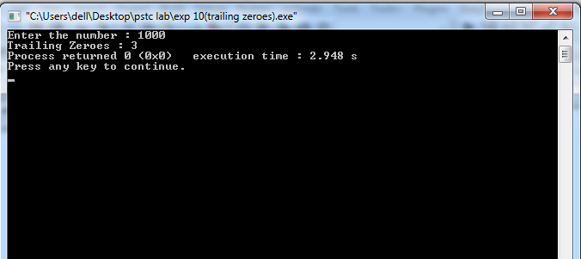
Q11. STATEMENT: C Program to Check if a given Integer is Power of 2 using Bitwise Operators

CODE:
#include <stdio.h>
int main()
{
int num,count=0;
printf("Enter number : ");
scanf("%d",&num);

while(num)
{
if(num&1==1)
{
count++;
}
num>>=1;
}
if(count==1)
{
printf("YES!!!!");
}else
{
printf("NO!!!!");
}
return 0;
}

OUTPUT :

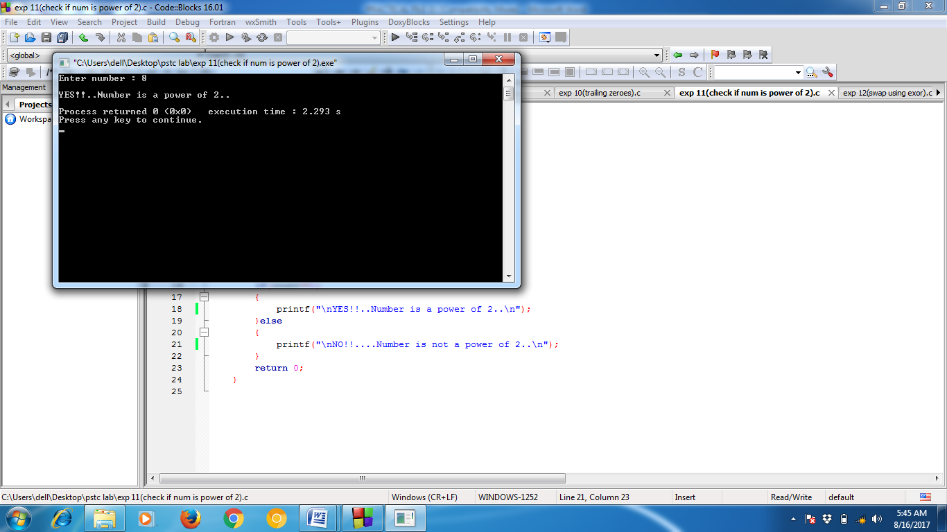

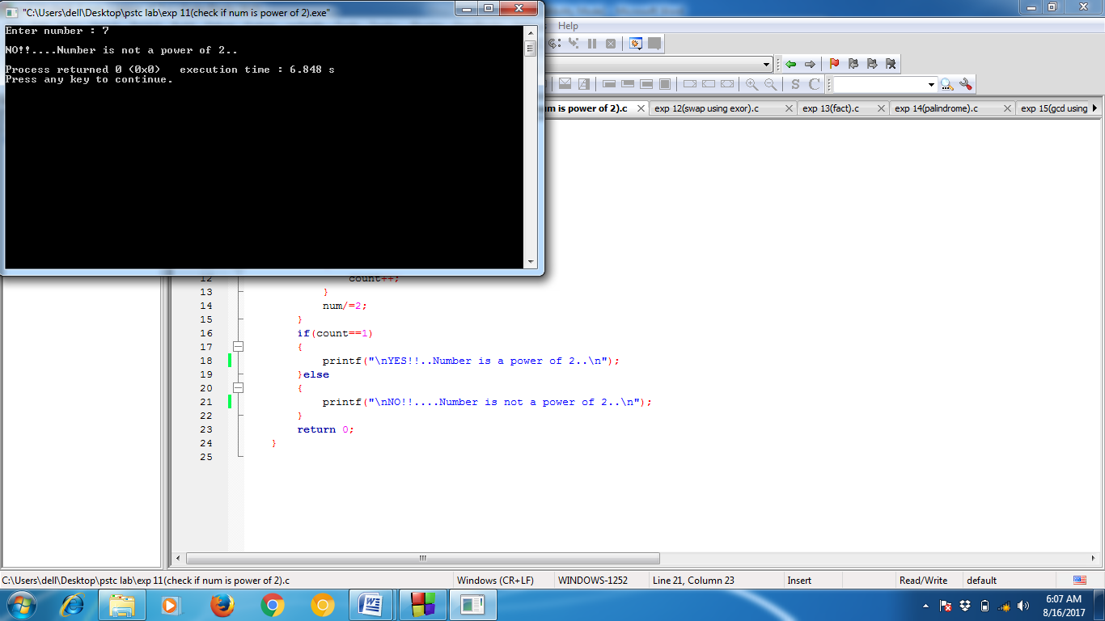

Q12. STATEMENT: WAP to swap two numbers using bitwise XOR Operator.

CODE:
#include <stdio.h>
int main()
{
int num1,num2;
printf("Enter num1 and num2 : ");
scanf("%d %d",&num1,&num2);

num1=num1^num2;
num2=num1^num2;
num1=num1^num2;

printf("\nAfter swapping:\n");
printf("Num1 : %d\nNum2 : %d",num1,num2);
return 0;
}
OUTPUT :
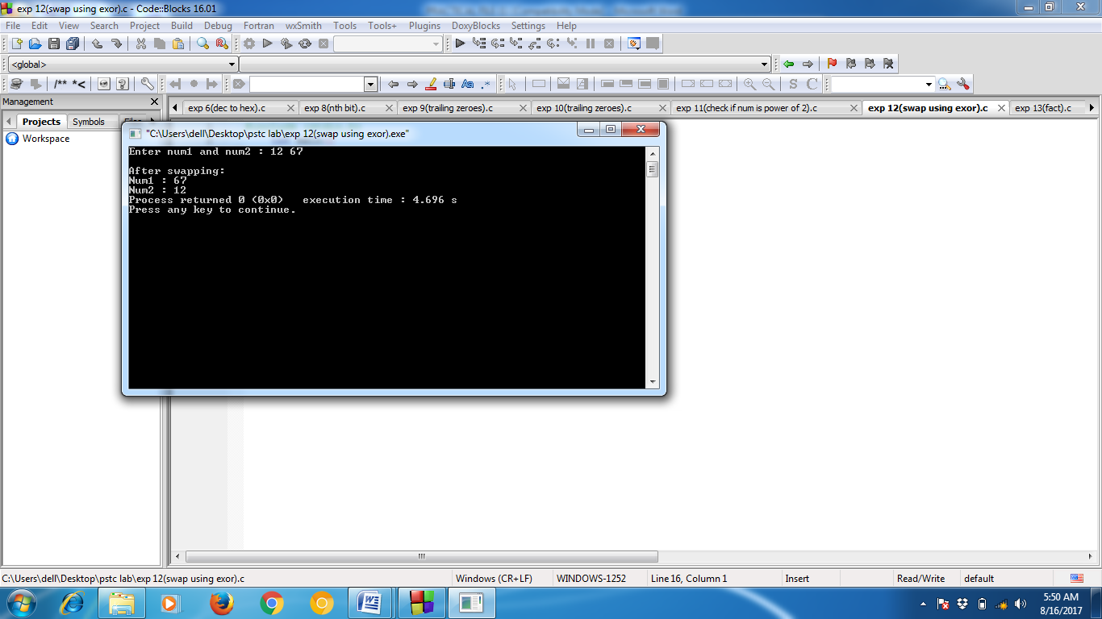

Q13. STATEMENT: Write a C program to find the factorial of a number, where the number is entered by user.

CODE:
#include <stdio.h>
int main()
{
int num,fact=1;
printf("Enter the number : ");
scanf("%d",&num);
while(num-1)
{
fact*=num;
num--;
}
printf("Factorial : %d",fact);
return 0;
}

OUTPUT :
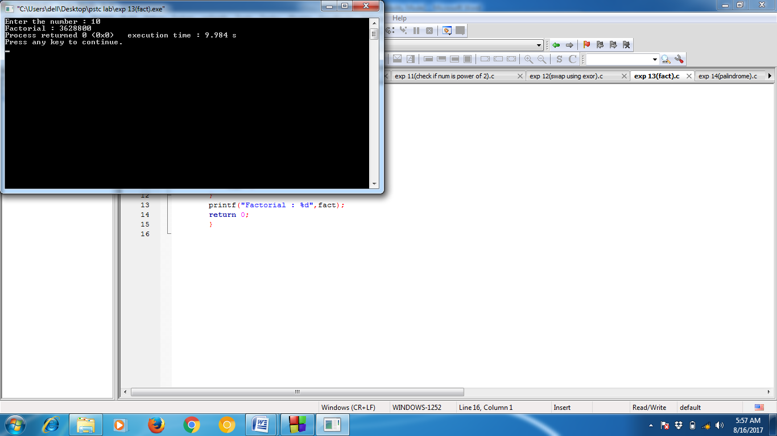

Q14. STATEMENT: WAP to check whether a number is palindrome or not.

CODE:
#include <stdio.h>
int main()
{
int num,rev=0,temp=0;
printf("Enter the number : ");
scanf("%d",&num);
temp=num;
while(temp)
{
rev=rev*10+temp%10;
temp/=10;
}
If (rev==num) {
printf("\nPalindrome Number..\n");
} else {
printf("\nNot a Palindrome Number..\n");
}
return 0; }
OUTPUT :
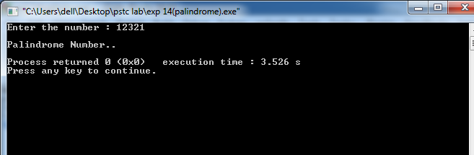
Q15. STATEMENT: WAP to calculate GCD of two numbers using Euclid’s algorithm.

CODE:

#include <stdio.h>
int euclid(int a, int b)
{
while (a != b)
{
if (a > b)
{
a = a - b;
}
else
{
b = b - a;
}
}
return a; // or b (since both are equal)
}

int main()
{
int a , b ;
printf("Enter the numbers :");
scanf("%d %d",&a,&b);
printf("euclid(%d, %d) = %d", a, b, euclid(a, b));
return 0;
}

OUTPUT :
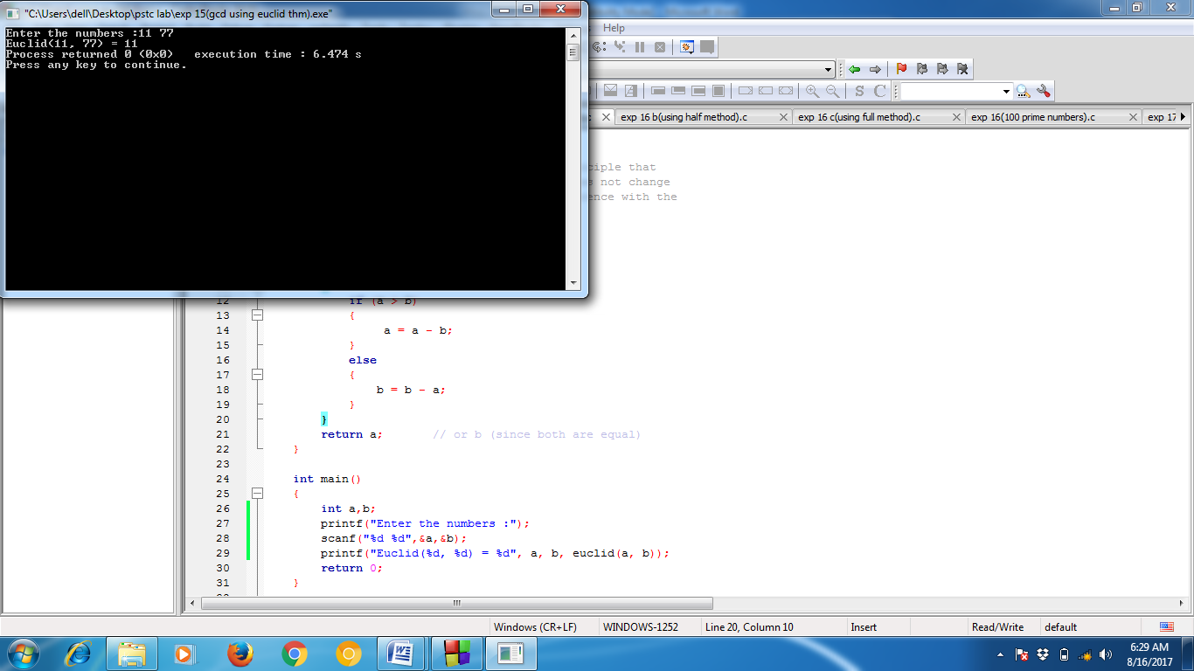

Q16. STATEMENT: WAP to find first 100 prime numbers (using square root method).

CODE:
#include <stdio.h>

int main()
{
int i,num=2,count=0,flag=0,k;

printf("First 100 prime numbers : \n");
while(count<100)
{
k=sqrt(num);
flag=0;
for(i=2 ; i<=k ; i++)
{
if(num%i==0)
{
flag=1;
break;
}
}
if(flag==0)
{
printf("%d\t",num);
count++;
}
num++;
}
return 0;
}
OUTPUT :

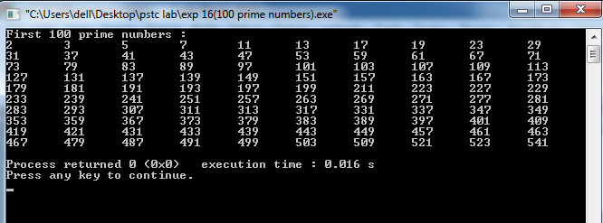
Q17. STATEMENT : C Program to Display Fibonacci Series

CODE:
#include <stdio.h>
int main()
{
int a=0,b=1,c=0,count=0,len;
printf("Enter the length of seris : ");
scanf("%d",&len);

printf("\n");
while(count<len)
{
printf(" %d ",c);
a=b;
b=c;
c=a+b;
count++;
}
printf("\n");
return 0;
}

OUTPUT :

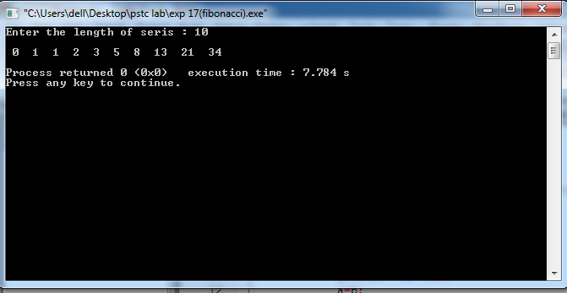

Q18. STATEMENT : WAP to find whether a number is Armstrong or not.

CODE:
#include <stdio.h>
int no_of_dig(int num)
{

int count=0;
while(num)
{
count++;
num/=10;
}

return count;

}

int main()
{
int num,sum=0,temp,a,dig;
printf("Enter number : ");
scanf("%d",&num);

dig=no_of_dig(num);
temp=num;

while(temp)
{
a=temp%10;
sum+= pow(a,dig);
temp/=10;
}

if(sum==num)
{
printf("Armstrong number..");
}else
{
printf("Not a Armstrong number..");
}

return 0;
}

OUTPUT :

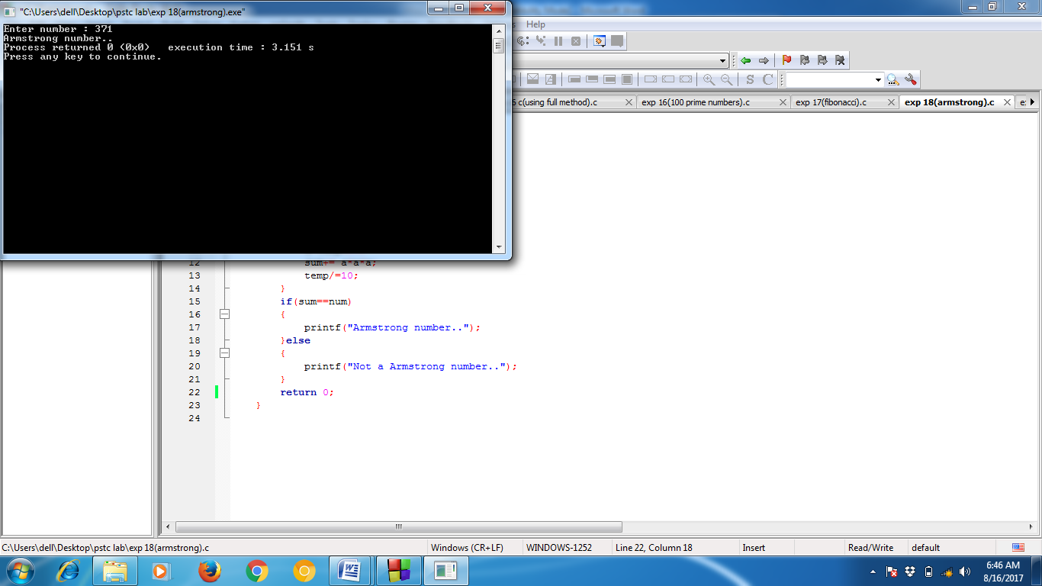

Q19. STATEMENT : C Program to Convert Binary Number to Decimal and Decimal to Binary

CODE:
#include<stdio.h>
#include<math.h>
int main()
{
int num,c=0,result;
printf("Enter number : ");
scanf("%d",&num);
result=b_num(num,c);
d_num(result);
return 0;
}
int b_num(int num,int c)
{
int rem,b_num=0,i=0;
while(num)
{
rem=num%2;
num=num/2;
b_num=b_num+rem*pow(10,i);
i++; }
printf("binary number = %d",b_num);
return(b_num);
}
void d_num(int result)
{
int r,j=0,d_num=0;
while(result)
{
r=result%10;
result/=10;
d_num=d_num+r*pow(2,j);
j++; }
printf("\ndecimal number = %d",d_num);
}
OUTPUT :
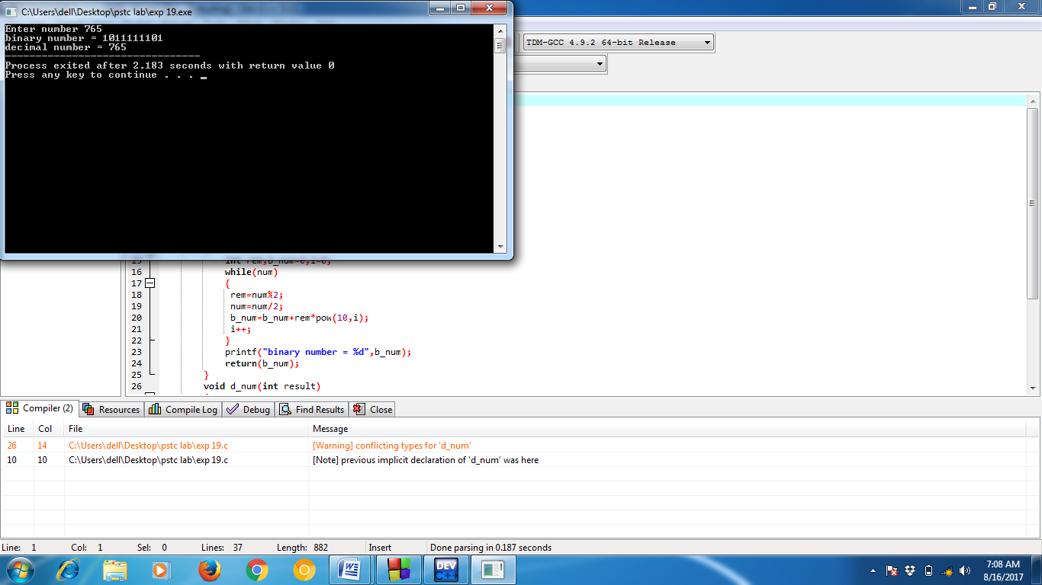
Q20. STATEMENT : C Program to Convert Decimal to Octal and Octal Number to Decimal .

CODE:
#include<stdio.h>
#include<math.h>
int main()
{
int num,c=0,result;
printf("enter number ");
scanf("%d",&num);
result=o_num(num,c);
d_num(result);
return 0;
}

int o_num(int num,int c)
{
int rem,o_num=0,i=0;
while(num)
{
rem=num%8;
num=num/8;
o_num=o_num+rem*pow(10,i);
i++;
}
printf("octal number = %d",o_num);
return(o_num);
}

void d_num(int result)
{
int r,j=0,d_num=0;
while(result)
{
r=result%10;
result/=10;
d_num=d_num+r*pow(8,j);
j++;
}
printf("\ndecimal number = %d",d_num);
}
OUTPUT :

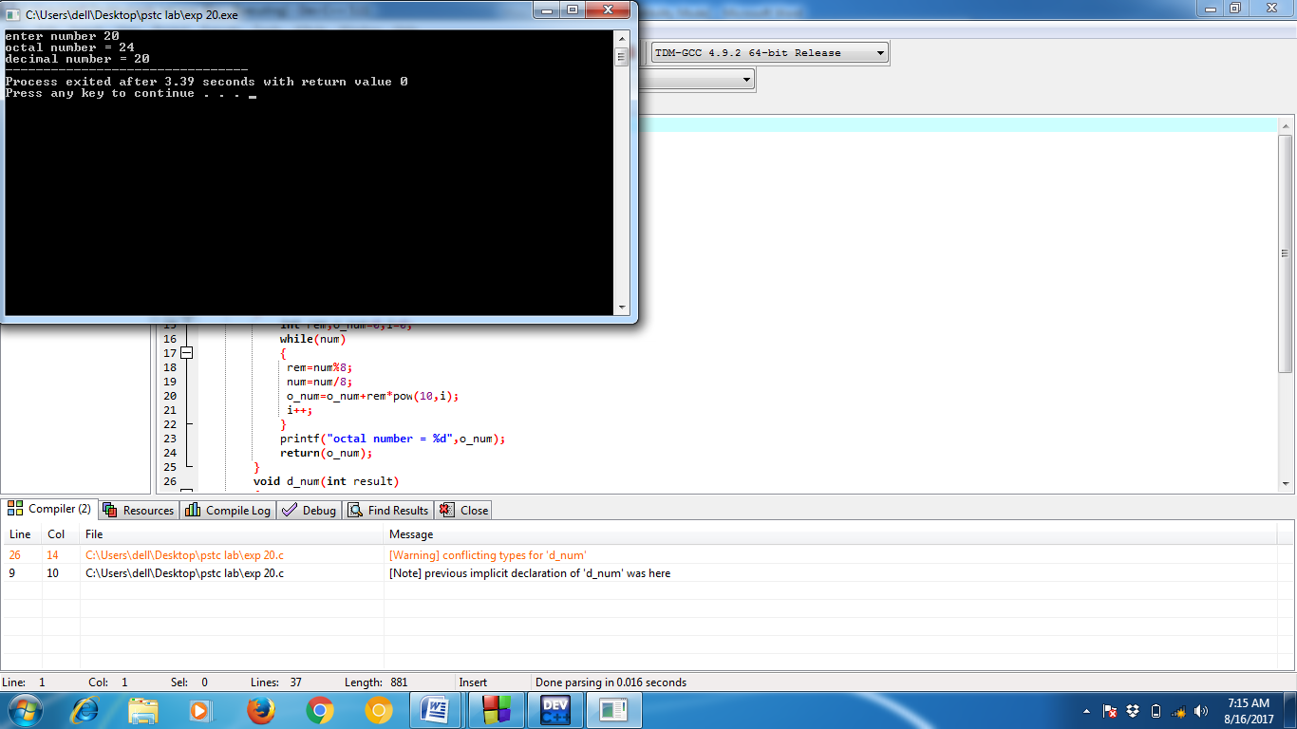

Q21. STATEMENT : C Program Swap Numbers in Cyclic Order Using Call by Reference

CODE:

#include <stdio.h>
void swap(int* a,int* b)
{
int temp;
temp = *a;
*a = *b;
*b = temp;
printf("a=%d, b=%d",*a,*b);
}
int main()
{
int a,b,sum;
printf("Enter 2 numbers : ");
scanf("%d %d",&a,&b);
swap(&a,&b);
return 0;
}

OUTPUT : 